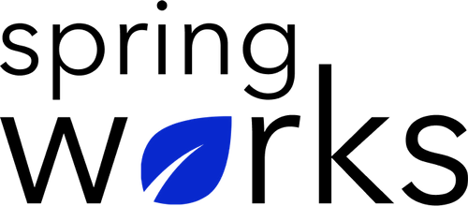
Free Template – Employee Attitude Survey

Use this survey to see what employees think about their work and workplace.

This employee attitude survey will help you determine what’s good about your work and the workplace and what you think could be improved. Copy this template to your Google Drive and customize it for your organization.

Communication (to be added as review instructions):

We can only make positive changes when we have the right information. All answers you give will be treated with the utmost sensitivity, and the information will not be used for any other purpose apart from planning and improvement. Please answer this quick survey by <HOUR OF THE DAY> on <DATE>.

Demographic Information:

The following information is requested so that meaningful analysis and comparisons of group results can be made. Please check the circle, corresponding to your answer.

Q: Your Gender:

- Male
- Female

Q: Your Department:

- Marketing
- Operations
- Tech
- Accounting
- HR

Q: Company Service:

- Under 1 Year
- 1-2 Year
- 3-5 Year
- 6-10 Year
- 10-15 Year
Employee Attitude Questionnaire

To answer clearly what you think or feel about each item, please follow these steps:

- Read each item fully before you start to mark your answer.
- Pick the one answer which most nearly says what you think or how you feel.
- While completing the questions, be sure to read the special instructions which are included.

Choose the answer which is most appropriate (Strongly Agree = 5 and Strongly Disagree =1)

Q: I have asked for training to do my job better:

- 5
- 4
- 3
- 2
- 1
- N/A

Q: I received training when I asked for it:

- 5
- 4
- 3
- 2
- 1
- N/A

Q: I could be better at my work if I had some/more training or professional development:

- 5
- 4
- 3
- 2
- 1
- N/A

Q: I have the right tools and resource to do my job:

- 5
- 4
- 3
- 2
- 1
- N/A

Q: When change is about to happen, I am consulted:

- 5
- 4
- 3
- 2
- 1
- N/A

Q: I think people appreciate the work I do:

- 5
- 4
- 3
- 2
- 1
- N/A

Q: I am paid the right amount of money for the work I do:

- 5
- 4
- 3
- 2
- 1
- N/A

Q: I would be interested in trading some workplace benefits in lieu of financial pay:

- 5
- 4
- 3
- 2
- 1
- N/A

(If you agree, please list the benefits you’d like).

Q: I always get constructive feedback about my work

- 5
- 4
- 3
- 2
- 1
- N/A

Q: The company cares about me as a person as well as an employee:

- 5
- 4
- 3
- 2
- 1
- N/A

Q: I am kept informed on how well my own department area performs

- 5
- 4
- 3
- 2
- 1
- N/A

Q: The people I work with cooperate to get the job done.

- 5
- 4
- 3
- 2
- 1
- N/A

Q: My job makes good use of my skills and abilities.

- 5
- 4
- 3
- 2
- 1
- N/A

Q: I would recommend this organization to others as an employer:

- 5
- 4
- 3
- 2
- 1
- N/A

Q: I would recommend the company as a provider of products and/or services:

- 5
- 4
- 3
- 2
- 1
- N/A

Q: The best three things about working here are:

i.
ii.
iii.

Q: The three things I would most like to see improved are:

i.
ii.
iii.

Q: What else would you like to tell us about?

Many thanks for taking the time to fill in this survey.

